3.1 (b)

|  |  |  |  |
| --- | --- | --- | --- |
|  | Peak freq. (kHz) | 3dB BW (kHz) | Quality Factor |
| C=100pF | 514 | 3.32 | 155 |
| C=30pF | 938 | 14.9 | 63 |

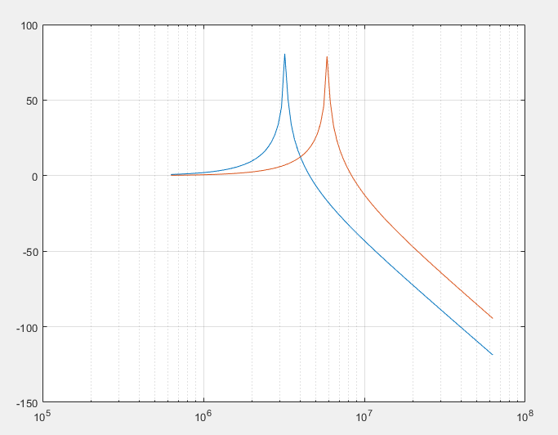

For C=30pF part,ω0=9.3*105Hz,BW3DB=9kHz,QF=105

For C=100pF part,ω0=5.1*105Hz,BW3DB=5kHz,QF=102

The peak frequencies are very close while there exists some difference in other values between the calculation and figure. I think it’s because I get the number directly from the figure, which is not accurate enough.

3.2(c)

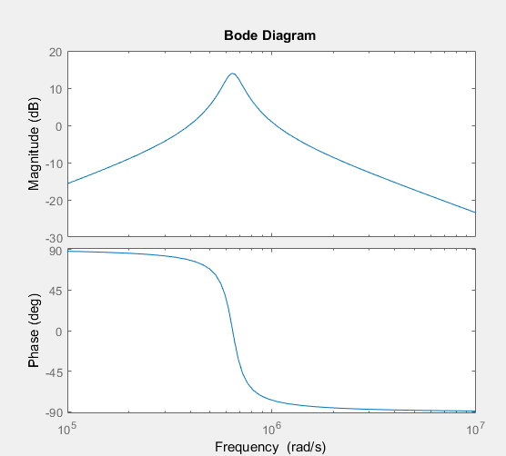

From the figure, ω0=6.37*105 rad/s=101kHz, H0=1014/20=5, BW3DB=1.33*105 rad/s

It’s very close to my calculated value